Analysis plan: Life expectancy by cancer type and stage in England

Rationale
GRAIL have developed a state-transition model which has been used in several publications to demonstrate the cost-effectiveness of asymptomatic MCED screening in a US population. Similar cost-effectiveness analysis within the English setting is planned to be performed to coincide with the publication of the NHS-Galleri primary results.
Effectiveness in such analyses is typically reported in terms of life years and quality-adjusted life years. Within the GRAIL cost-effectiveness model, the age and stage at which a cancer is diagnosed under usual care and under an MCED screening programme scenario is simulated, and age-, cancer type-, and stage-specific estimates of (quality-adjusted) life expectancy are then assigned to individuals diagnosed with cancer. In order to adapt the GRAIL cost-effectiveness model to the English setting, it is necessary to incorporate English estimates of age-, cancer type, and stage-specific (quality-adjusted) life expectancy. Suitable estimates, however, do not currently exist in the literature, providing the primary motivation for this study.
Primary study outcome: Life expectancy at diagnosis by cancer type, stage, and age.

Additionally, building on the estimation of life expectancy, years of life lost (YLL) in relation to the general population’s life expectancy provides an intuitive and impactful metric of the mortality benefit of earlier diagnosis. By demonstrating meaningful differences in YLL by stage across all cancer types, we can rebut two key objections to MCED screening. Firstly, by focusing on a long-term mortality-based outcome, YLL overcomes lead-time bias and can counter the objection that lead-time and/or length time biases explain the observed survival benefit of cancer screening. Secondly, YLL are shown to be lower at earlier stages across the spectrum of stageble cancer types, and can counter the objection that lethal cancers have a high mortality rate across all stages, so there is no benefit to early detection.
Secondary study outcome: Years of life lost at diagnosis by cancer type, stage and age.

Methods

Survival extrapolation method for life expectancy estimation
A myriad of methodologies have been developed for the purposes of extrapolating survival functions from observed data.^{1–7} Generally, these methodologies involve the fitting of parametric survival models to observed survival data, with many incorporating additional information, such as general population mortality, to inform the survival function. Some methodologies utilise an all-cause survival framework where only the all-cause survival function is considered.^{8–10} Others use a relative survival (additive hazard) framework, where relative survival ($R(t)$) is defined as the all-cause survival ($S_{ac}(t$)) divided by the expected survival without the disease ($S_{exp}(t)$), $R(t)=\frac{S_{ac}(t)}{S_{exp}(t)}$. In such a framework, the relative survival is estimated using the given observed all-cause survival and expected survival (from general population life tables), with the relative and expected survival functions subsequently extrapolated separately before being combined, potentially leading to more reliable extrapolations.⁶
For this analysis, we will utilize a Bayesian flexible parametric survival model.^{11,12} The advantage of this model is its comprehensiveness and flexibility: it can incorporate external data such as aggregate counts that encompass typical registry data, it can be specified to use either an all-cause or a relative survival framework, and a mixture-cure model can also be incorporated.
Briefly, the framework directly models the mortality hazard(s) over time as a piecewise or smooth function using an M-spline model.¹³ For the model, a prespecified number and placement of knots splits time into intervals, with each interval then associated with a cubic polynomial function. The hazard(s) of death at a given time is calculated based on the weighted average of these functions at that time. The Bayesian flexible parametric survival model has been developed into an R package. At the package's core is the survextrap() function, which when run estimates the survival model fit. The key survextrap() function arguments are:

- formula: Here, the survival formula is specified following normal R formula syntax for a survival object, i.e. Surv(time, event) ~ X, where X constitutes any covariates (none in our model, therefore ~ 1).

- data: The all-cause survival data set, with a time column (follow up time) and an event column (typically 0=alive, 1=dead )

- external: External data can be supplied to the model through this argument. The model can be run with external data only, without the need for individual-level survival data in the data argument. External data needs to take the following form: out of $n_{j}$ people alive at a time $t_{j}$, $r_{j}$of them survive until the time $u_{j}$. Where $j$ is the data index from $j$ = 1, … J
Table 1: Data format required for the external argument.
Start time | End time | Alive at $t$ | Still alive at $u$
$t_{1}$ (e.g. 0) | $u_{1}$(e.g. 1 year) | $n_{1}$ | $r_{1}$
… | … | … | …
$t_{J}$ | $u_{J}$ | $n_{J}$ | $r_{J}$

- backhaz: Either NULL, or a data set containing the background hazards of death by time period, providing the information on the expected survival. When backhaz is specified, a relative survival framework is used.

- cure: when set to TRUE, a mixture cure model is specified. This can be done within the relative survival framework, and is applied to the excess mortality hazard. Priors can be set for the cure proportion. If not given, then default ‘non-informative’ priors are used.

- mspline: A list of control parameters defining the spline model. Of particular interest is the df (degrees of freedom) parameter. The Degrees of freedom is the number of parameters (or basis terms, regions between knots) intended to result from choosing knots based on quantiles of the data. The default is 10.

- fit_method: either "mcmc" or "opt". "Mcmc" is standard (Hamiltonian) Markov Chain Monte Carlo sampling (via rstan's rstan::sampling() function). It is the most accurate but the slowest method. When “opt” is specified, then instead of an MCMC sample from the posterior, survextrap returns the posterior mode calculated using optimisation, via rstan's rstan::optimizing() function. This is much quicker, however it is less accurate. The model documentation suggests using “opt” for model development, while using “mcmc” for the "final answer".

Data
For the analysis, overall survival estimates for England provided by the National Cancer Registration and Analysis Service (NCRAS) will form the basis of survival observations used in the Bayesian flexible parametric survival models. Granular overall survival estimates up to 10-year after diagnosis have been requested for 25 cancers (using GRAIL cancer_type_sap definition) by AJCC stage (I to IV, Unstageable, Unknown), sex, and 5-year age bands from 40 to 84 years of age, as well as an 85+ category. The overall survival estimates are based on cancer diagnosis registrations between 2013-2022. Overall survival estimates will also be provided for two sub-period; 2013-2017, and 2018-2022.

Table 2: Abbreviated data request specification for overall survival (%)
Cohort diagnosis | Sex | Age Group | Cancer Type | Stage at Diagnosis | Years since diagnosis | Overall survival (%) | Number of patient | Number of deaths
2013-2022 | Persons | 40-44 | Anus | 1 | 0.083
2013-2017 | Male | 45-49 | Bladder | 2 | 0.167
2018-2022 | Female | 50-54 | Breast | 3 | 0.25
 |  | 55-59 | Cervix | 4 | 0.333
 |  | 60-64 | Colon/Rectum | Unstageable | 0.417
 |  | 65-69 | Gallbladder | Unknown | 0.5
 |  | 70-74 | Head and Neck |  | 0.75
 |  | 75-79 | Kidney |  | 1
 |  | 80-84 | Liver/ Bile-duct |  | Three monthly intervals to
 |  | 85+ | Lung |  | 5
 |  |  | Lymphoid Leukaemia |  | Six-monthly intervals to
 |  |  | Lymphoma |  | 10
 |  |  | Myeloid Neoplasm
 |  |  | Melanoma
 |  |  | Oesophagus
 |  |  | Ovary
 |  |  | Pancreas
 |  |  | Plasma Cell Neoplasm
 |  |  | Prostate
 |  |  | Sarcoma
 |  |  | Stomach
 |  |  | Thyroid
 |  |  | Urothelial Tract
 |  |  | Uterus
 |  |  | Other

To inform the survival extrapolation, general population mortality rates are required. These will be obtained from English national life tables which are published by the Office for National Statistics. The most recently published English national life table covers the period 2021 to 2023. The 2022 to 2024 may be published by the time this analysis is performed.
The published life tables are provided separately for each sex and provide the central mortality rate at age x (mx) and the average life expectancy at age x (ex) for each 1 year age band. The central mortality rates will be used as the background hazard in the Bayesian flexible parameteric survival model, and the average life expectancy for the YLL calculation.
Table 2: Life table format
Age | mx | qx | lx | dx | ex
0 | 0.004532 | 0.004521 | 100000 | 452.1 | 78.82
1 | 0.000244 | 0.000244 | 99547.9 | 24.3 | 78.17
… | … | … | … | … | …

Estimation procedure and considerations

Assumed age for survival extrapolation and years of life lost
The overall survival data will be provided in 5-year age bands, whilst the general population mortality data will be in 1-year age increments. For the survival extrapolation, therefore, an appropriate start point for the general population mortality rates needs to be chosen. I.e. for the 50-54 year age band, this could be anywhere between 50 and 55 years of age. For the years of life lost estimation, again general population life expectancy is given in 1-year age increments, which the life expectancy estimates need to be subtracted from to produce the YLL. Again, for the 50-54 year age band, this could be the life expectancy anywhere between 50 and 55 years of age.
It is proposed that the midpoint of the age-band is used as the start of general population mortality rates for the survival extrapolation, and for the general population life expectancy comparison. As this is a 0.5 increment, i.e. for the 50-54 age group 52.5 is the mid point, it is proposed that interpolation using a natural cubic spline fit to the mortality rates/life expectancies is used to estimate the mortality rate/life expectancy in the 0.5 year increments.
To be agreed: The mid point of the 5-year age band should be used for survival extrapolation and YLL estimation, with the 0.5 year increments obtained through interpolation.

Input survival format
In the Bayesian flexible parametric survival model function, survextrap(), the observed survival data can take the form of either (1) time-to-event data supplied to the data argument or (2) aggregated data supplied to the external argument of the surextrap() function.
The variables in the data request; years since diagnosis, number of patients, and number of deaths, will enable us to populate the external data argument as required e.g.
Table 3: Data format required for the external argument example
Start time | End time | Alive at start | Still alive at end
0 | 0.083 | number of patients at start time | number of patients at start time - number of deaths
0.083 | 0.167 | number of patients at start time | number of patients at start time - number of deaths
… | … | … | ..

Alternatively, another approach is to reconstruct the original time to event data from the aggregated data provided by NDRS, and input this into the data argument. When the life expectancy work was being performed on the NDRS 5-year net survival data, as the data did not contain the number of deaths, this approach was taken. Guyot et al (2012) proposed a popular algorithm for reconstructing time to event data from give survival times, survival, and number-at-risk estimates, often derived from published Kaplan-Meier plots.⁸ This reconstruction method can again be performed on the new NDRS data request using the years since diagnosis, number of patients (number at risk), and overall survival variables.
Pragmatically, it would be most comprehensive to try both approaches to see if there is concordance as to the model fits that the survextrap() function produces, as well as whether it affects model convergence.
To be agreed: Both approaches to input survival data will be compared. If they are seemingly equivalent, the (2) aggregated data approaches will be used

Differential mortality
In the UK cost-effectiveness analysis decision problem, it is specified that we want to incorporate data on mortality associated with shedding vs non-shedding cancers. Previously, in the Modelled Mortality paper, scenarios in which the hazard ratio of death for a cfDNA+ tumour over a cfDNA- were applied to the 5-year net survival data used in that study, and it is proposed the same method is applied in this study.¹⁴ The adjustment method uses the test sensitivity (for the cancer type and stage being looked at) and the hazard ratio of mortality to estimate survival for the cfDNA+ and cfDNA- sub-populations, ensuring that, given their proportions (based on test sensitivity), the combined population survival is preserved.
To be agreed: The same method as previous will be used. The hazard ratio will apply for the full observed survival period, 10 years, without waning. A singular hazard ratio should be chosen: The hazard ratio between cancers with a CSD and no CSD from the 5-year follow-up of CCGA3 was estimated to be 1.67.

Sensitivity analysis - Cure assumption
The Bayesian flexible parametric survival model can be specified to run as a mixture cure model. In the US SEER YLL analysis, a mixture cure model was specified as the primary model, with cure probability priors informed by prior work performed by Paradigm Support.¹⁵ In a sensitivity analysis, a normal non-mixture cure model was instead specified. It is proposed that a similar sensitivity analysis should be performed for this study.
Below for interest, resulting life expectancy estimates for the two model specifications are shown across age and sex strata for lung cancer. Generally, the mixture-cure specification produced higher estimates of life expectancy, with the difference often greater at younger ages and lower stages. This may reflect the particular cure probabilities used as priors, or a common difference when using mixture-cure models.
To be agreed: Which specification should be our primary analysis and which should be a sensitivity analysis. For the sensitivity analysis, should this be performed for a few cancer types or all.

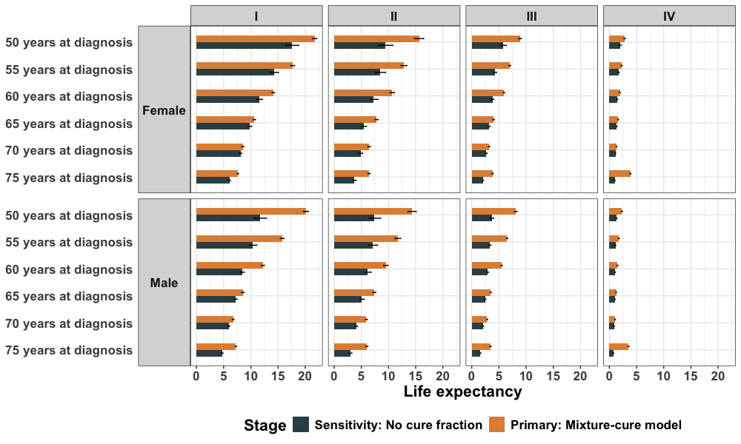

Sensitivity analysis - period of diagnosis
As well as requesting overall survival data for patients diagnosed between 2013-2022, two sub-periods were also specified; 2013-2017 and 2018-2022. The first sub-period will have overall survival data up to 10-years post-diagnosis, whilst the later sub-period will have up to 5-years. To identify potential period effects, as a sensitivity analysis it is proposed that, at least for some cancer types, life expectancy estimates are generated based on the two sub-period overall survival data. This raises the questions of what is the appropriate life table to inform expected survival - should an early life table be used for the 2013-17 sub-period.
To be agreed: Whether a sensitivity analysis should be performed to create life expectancy estimates for the different sub-period. It is suggested the six following cancers are looked at: breast, colorectal, head and neck, lung, lymphoma, and prostate. Which life tables are the most pertinent for providing expected survival.

Code overview
The code for this analysis is written in R. There are four analysis scripts, five function scripts, and an input data folder. The data folder will contain the overall survival data received from NDRS (it currently contains the 5-year net survival data for the code review), the chosen life table(s) (for code review 2017-2019), and test sensitivity by cancer type and stage from CCGA3 (used in the differential mortality estimation).
The first analysis script, 01_prep_surv.R, prepares the data. It begins by loading in the functions and data files. Next, the spline-based interpolation of the 1-year central mortality rates and life expectancy is performed. The below figure presents the 1-year interval hazard and mortality (purple points) from the 2017-19 English life table with the resulting cubic spline (gold line). Ultimately, the difference between mortality hazards and life expectancy between each year of attained age is minimal, therefore performing the interpolation and using the exact mid-point is unlikely to make much of a difference compared with for instance using the 3 year interval point e.g. 53yrs for the 50-54 age band.
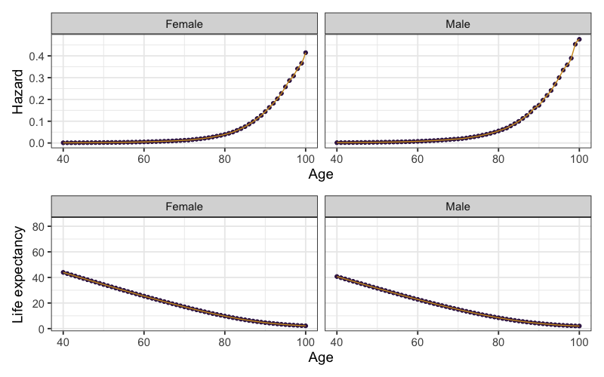

An element of data cleaning is then performed on the survival data which is specific to the net survival data currently read in, and therefore is likely to be changed when the new overall survival data is obtained. The differential mortality procedure is then performed using the f_derive_surv_cfDNAstatus() function contained in the equivalent named function script. In the function, each aggregated overall survival point, i.e. the overall survival at time 0.083, 0.167, etc, is split into an overall survival estimate for the cfDNA- patients and cfDNA+patients. This is done first for cfDNA- patients through optimising (finding the minimum) of the following function with respect to X over the interval [0, 1]:
${(X^{HR}* cfDNA detection rate) + X*(1- cfDNA detection rate)-OS)}^{2}$
Where:
$X=overall survival to be calculated{, OS}_{cfDNA-}$
$HR= the hazard ratio of mortality$
$cfDNA detection rate = test sensitivity for the cancer type and stage$
$OS=The observed whole group overall survival$
The overall survival is then estimated for the cfDNA+ group by assuming proportional hazards between the two groups:
${{OS}_{cfDNA+} = {{OS}_{cfDNA-}}^{HR}}_{}$
In the script, the differential survival is then plotted to allow for checking. Below is an example using the net survival data.
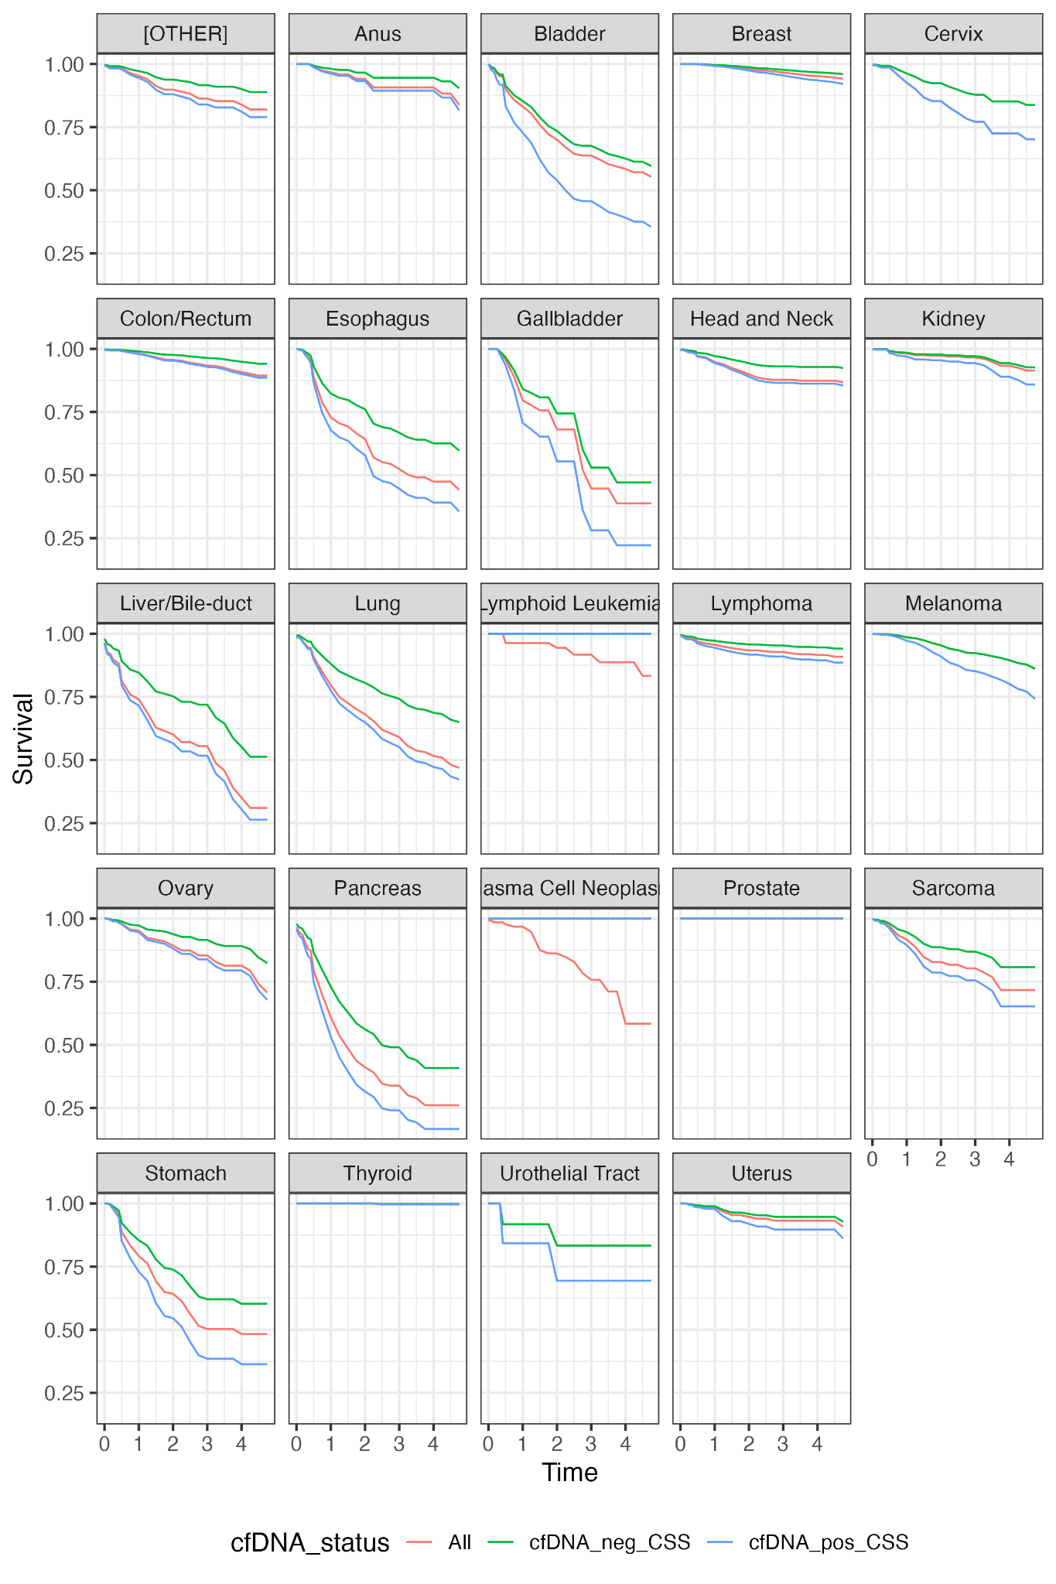

Now the data is prepared, the 02_analysis_M_spline_splitbysite.R analysis script performs the life expectancy estimation. Life expectancy estimates will be produced for a large number of patient presentations. For lung cancer, for instance, separate life expectancies will be estimated for the exhaustive combination of each age group (10 categories: 40-45:85+), stages (I:IV), sexes (female, male), and hazard ratio X cfDNA status (No HR, HR cfDNA+, HR cfDNA-). This totals 10*4*2*3 = 240 combinations for lung alone.
Given the computational load of doing this, to minimise the potential for computer crashes to lose work the script splits the survival dataframe into different cancer types. Then for each cancer type, there is repetition of the same chunk of code, e.g. for anal cancer:


temp <- df_surv_byHR %>% filter(NCRAS_Draw == "Anus") %>%
mutate(across(where(is.factor), as.character)) %>%
mutate(across(where(is.character), as.factor))

l_res_anus <- map(.x = split(temp, list(Sex, Stage, Age, HR, cfDNA_status)),
.f = safely( ~f_life_exp(survival = .x,
include_additive_hzds = TRUE,
include_cure_fraction = specify_cure,
plotsurvhz = FALSE,
survextrap_add_knotts_interval = NA,
survextrap_fit_method = specify_method,
survextrap_niter = specify_n_interation)))

write_csv(f_LE_summary_table(l_res_anus), paste0(specify_res_save_path, specify_meth_name, "_LE_Anus.csv"))
write_csv(f_LE_errors(l_res_anus), paste0(specify_res_save_path, specify_meth_name, "_errors_Anus.csv"))

In this chunk, the cancer type specific dataframe (temp) is split into sub-dataframes of the exhaustive combinations listed above. These dataframes are passed to the f_life_exp() function where the survival model fitting and life expectancy estimation is performed for each one. A function called safely wraps around the f_life_exp() function so that if there is an error in the survival fitting process, the error is logged but the chunk continues to the next patient combination instead of erroring out. All the life expectancy estimates and run errors are collected by the l_res_anus object, and the functions f_LE_summary_table() and f_LE_errors() neatly write these onto file.
The f_life_exp() function is essentially a (self-created) wrapper function for the survextrap() function. It gets the age and sex of the patient presentation under evaluation, and filters the general population mortality data to this age and sex range. Currently, it then performs the Guyot et al (2012) procedure on the given (net) survival data, making use of the survHE package’s implementation of theGuyot algorithm. It then calls the survextrap() function to fit the model on the created time-to-event based on options specified in the f_life_exp() function arguments. Below shows this later code chunk from the function.
#' Run the survextrap function with functionality to specify
#' a relative survival frame work and mixture cure model

if(include_additive_hzds){
if(include_cure_fraction){
#'Relative survival frame work + mixture cure model
model <- survextrap::survextrap(Surv(time, event) ~ 1,
data=surv_IPDdata,
mspline=mspline,
backhaz = get_bckgrnd_hz,
cure = TRUE, fit_method = survextrap_fit_method)
print("Model with backhaz and cure probability")

} else {
#' Relative survival frame work no cure assumption
model <- survextrap::survextrap(Surv(time, event) ~ 1,
data=surv_IPDdata,
mspline=mspline,
backhaz = get_bckgrnd_hz,
fit_method = survextrap_fit_method)
print("Model with backhaz")
}
} else {
#' All-cause survival frame work with no background mortality
model <- survextrap::survextrap(Surv(time, event) ~ 1,
data=surv_IPDdata,
mspline=mspline,
fit_method = survextrap_fit_method)
print("Model on observations only")
}
Next, the f_life_exp() function estimates the restricted mean survival time up to 100 years of age from the survival model fitted by survextrap(), using the package’s rmst() function. This is taken as the life expectancy estimate. Note that by default the median from the posterior is used, and the 0.025, 0.975 quantiles used for the 95% credible interval
if(include_additive_hzds){
#' Calculate restricted mean survival time (up to 100 years of age)
#' By default this is the MEDIAN from the posterior: "default=
#' list(median=median, ~quantile(.x, probs=c(0.025, 0.975)))
rmst_mod <- rmst(model, t = 100 - get_age, niter = survextrap_niter)
} else {
#' Restrict the all-cause estimate a bit here
rmst_mod <- rmst(model, t = 12, niter = survextrap_niter)
}


The third analysis script 03_post_analysis_check.R, loads in the life expectancy tables saved in the prior script. In it, a template dataframe with all potential combinations is first created, with the life expectancy tables then merged on. This creates a table showing the patient presentations where the model failed to run, which can be cross referenced with the error tables. Finally, the 04_LE_and_YLL.R writes out the life expectancy results more neatly. It then performs the YLL calculations, where the life expectancy estimate (and credible interval) is taken away from the general population life expectancy at the midpoint of the age-band under consideration.

References
1. Sweeting MJ, Rutherford MJ, Jackson D, et al. Survival Extrapolation Incorporating General Population Mortality Using Excess Hazard and Cure Models: A Tutorial. Med Decis Making. 2023;43(6):737-748. doi:10.1177/0272989X231184247
2. Andersson TML, Dickman PW, Eloranta S, Lambe M, Lambert PC. Estimating the loss in expectation of life due to cancer using flexible parametric survival models. Stat Med. 2013;32(30):5286-5300. doi:10.1002/sim.5943
3. Rutherford MJ, Andersson TML, Björkholm M, Lambert PC. Loss in life expectancy and gain in life years as measures of cancer impact. Cancer Epidemiol. 2019;60:168-173. doi:10.1016/j.canep.2019.04.005
4. Bullement A, Stevenson MD, Baio G, Shields GE, Latimer NR. A Systematic Review of Methods to Incorporate External Evidence into Trial-Based Survival Extrapolations for Health Technology Assessment. Med Decis Making. 2023;43(5):610-620. doi:10.1177/0272989X231168618
5. Trouiller JB, Quenéchdu A, Toumi M, Boyer L, Laramée P. The Acceptance of Overall Survival Extrapolation Methods in Solid Tumor Treatments by Health Technology Assessment Agencies in England, France, and Australia between 2017 and 2022. Med Decis Making. Published online August 2, 2025:0272989X251351635. doi:10.1177/0272989X251351635
6. Chen EYT, Leontyeva Y, Lin CN, Wang JD, Clements MS, Dickman PW. Comparing Survival Extrapolation within All-Cause and Relative Survival Frameworks by Standard Parametric Models and Flexible Parametric Spline Models Using the Swedish Cancer Registry. Med Decis Making. Published online February 5, 2024:0272989X241227230. doi:10.1177/0272989X241227230
7. Jackson C, Stevens J, Ren S, et al. Extrapolating Survival from Randomized Trials Using External Data: A Review of Methods. Med Decis Making. 2017;37(4):377-390. doi:10.1177/0272989X16639900
8. Guyot P, Ades AE, Beasley M, Lueza B, Pignon JP, Welton NJ. Extrapolation of Survival Curves from Cancer Trials Using External Information. Med Decis Making. 2017;37(4):353-366. doi:10.1177/0272989X16670604
9. Che Z, Green N, Baio G. Blended Survival Curves: A New Approach to Extrapolation for Time-to-Event Outcomes from Clinical Trials in Health Technology Assessment. Med Decis Making. Published online October 31, 2022:0272989X221134545. doi:10.1177/0272989X221134545
10. Lee S, Lambert PC, Sweeting MJ, Latimer NR, Rutherford MJ. Evaluation of Flexible Parametric Relative Survival Approaches for Enforcing Long-Term Constraints When Extrapolating All-Cause Survival. Value Health. Published online October 17, 2023. doi:10.1016/j.jval.2023.10.003
11. Jackson CH. survextrap: a package for flexible and transparent survival extrapolation. BMC Med Res Methodol. 2023;23(1):282. doi:10.1186/s12874-023-02094-1
12. Timmins IR, Torabi F, Jackson CH, Lambert PC, Sweeting MJ. Simulation-based assessment of a Bayesian survival model with flexible baseline hazard and time-dependent effects. Published online March 27, 2025. doi:10.48550/arXiv.2503.21388
13. Brilleman SL, Elci EM, Novik JB, Wolfe R. Bayesian Survival Analysis Using the rstanarm R Package. Published online February 22, 2020. Accessed November 28, 2023. http://arxiv.org/abs/2002.09633
14. Sasieni P, Smittenaar R, Hubbell E, Broggio J, Neal RD, Swanton C. Modelled mortality benefits of multi-cancer early detection screening in England. Br J Cancer. Published online April 25, 2023:1-9. doi:10.1038/s41416-023-02243-9
15. Hubbell E, Clarke CA, Smedby KE, Adami HO, Chang ET. Potential for Cure by Stage across the Cancer Spectrum in the United States. Cancer Epidemiol Biomarkers Prev. Published online December 13, 2023:OF1-OF9. doi:10.1158/1055-9965.EPI-23-1018

